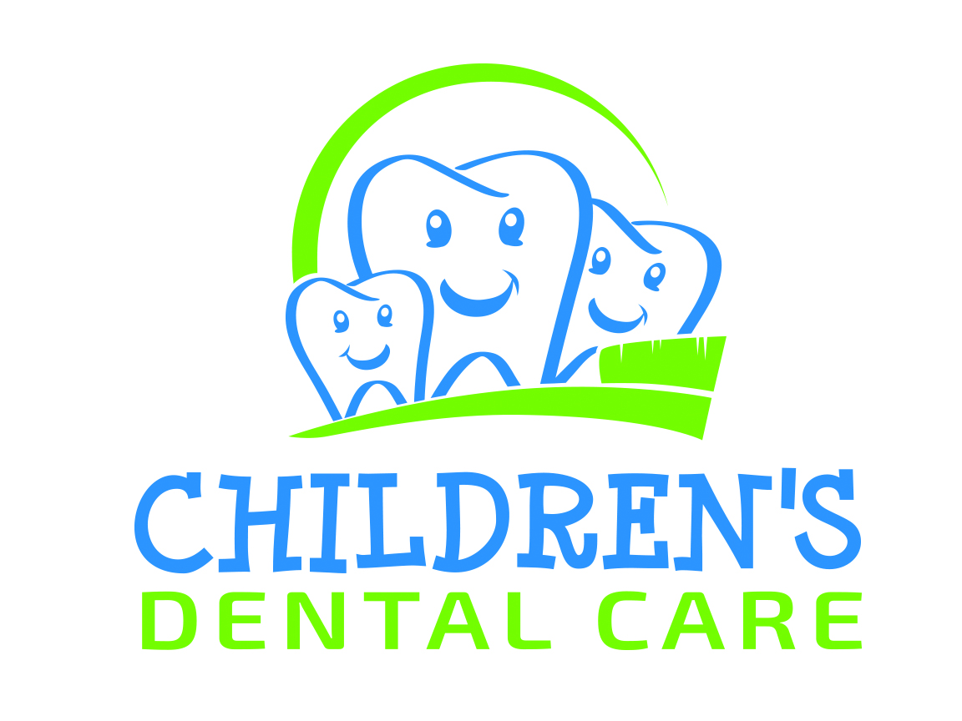
Lakeville Location: Savage Location:
17677 Cedar Ave 7629 Egan Drive
Lakeville, MN 55044 Savage, MN 55378
952-997-7100 952-440-5100

Brent R. Kvittem, DDS, MS Amy J. Kebriaei, DDS, MPH Katherine A. Nordeen, DDS, MSD Matt C. Husman, DMD

Dear Parent,

When your child visits Children’s Dental Care, you can expect the very best quality care for your child. As pediatric dental professionals, our mission is to provide quality comprehensive dental care that leads to an enjoyable experience for your child. Our office and staff is particularly trained and prepared to alleviate your child’s fear, apprehension, and anxiety of the dental visit. The comprehensive services we provide include everything from prevention (cleanings, fluoride treatments, sealants, and mouth guards) to treatment (fixing cavities either in the office or under general anesthesia and intermediate and full braces). Advances in dental technology in recent years have improved the dental experience for children with better dental restorative materials and pain free ways of providing care. Composite (white fillings), air-abrasion, and the wand® are three examples of these technologies utilized at Children’s Dental Care. The following, outlines the treatment, techniques and charges we institute for routine care.

- We provide an exam, cleaning, and fluoride treatment every six months.
Some insurance companies limit their coverage for fluoride treatments to once a year. We follow the American Academy of Pediatric Dentistry’s recommendation, which states, “Provide topical fluoride every six months.” Fluoride is given every six months unless you consult with our office prior to the treatment.

- Decay detecting x-rays (bitewings) are taken once a year or on an as needed basis.

- We are firm believers in sealant application to prevent decay in the grooves of teeth. Sealants are a protective plastic covering that is placed on the chewing service of the tooth, with about 90% reduction of decay in these grooves. We will guarantee sealants for up to three years of initial placement date to those patients who do not miss their six month check-up and are current patients to our office. Insurance companies may limit coverage for sealants. If you have questions regarding sealant coverage please check with your insurance company.

- We are a mercury free office. This means we do not place silver fillings we only place composite (white) fillings in our patient’s teeth. A comparison of traditional amalgams with composites reveals the following advantages of the new materials. Composites (1) are esthetically pleasing; (2) they do not contain mercury; (3) they actually adhere to the tooth surface; (4) They require less removal of sound tooth structure; and (5) are less irritating for the tooth nerves. Your insurance company may only cover up to 50% of these fillings to be placed. Please be advised that any balance remaining after insurance and or estimated patient portion has been paid is the patient’s responsibility. We will send in a pre-determination of dental benefits upon request for these services as a courtesy to you.

- Air abrasion is a technique used to remove tooth structure by spraying relatively small amounts of abrasion powder under pressure. The use of “the drill”, in many circumstances is not needed. Air abrasion eliminates odor, vibration, and most importantly pain. Therefore, in many situations, children do not need a local anesthetic (shot).

- In situations where it is necessary to numb a tooth, the wand® provides a more comfortable alternative to the traditional syringe “the shot”. The wand® is a computerized injection system that dispenses local anesthetic around the tooth in a relatively pain-free fashion. Thus the tooth will be numb, but not the tongue and the entire side of the face.

- Our financial policies are between the patient (parent) and our office, not the insurance company. We will attempt to aid you in collecting any covered benefits. The remaining balance is the patient’s responsibility.

We at Children’s Dental Care, hope this information will be helpful and that you will have a pleasant experience with our office.

Sincerely,

The Doctors and Staff at Children’s Dental Care

PATIENT INFORMATION

Patient’s Name: __________________________________________________________________________
Last First Full Middle
__Male__ Female Nickname: ____________________________ Birth Date: ________________________

DENTAL HISTORY

Reason for Dental Visit ______1st visit (new patient) ________new to area _______changed dentists
Has your child ever had trouble, problems or anxiety with previous dental care? _____yes _____no
If yes explain______________________________________________________________________________
Date of last dental visit ___________ Last x-rays ____________Last fluoride________________
Frequency of dental cleanings ________x a year
How often are your child’s teeth brushed? ________ flossed ____________ by whom ____________________
What age did your child stop nursing? _______________taking a bottle________________________________
Does your child take vitamins or fluoride supplements? ____ yes ____ no
Do you have fluoride in your water? ____yes ____ no

PLEASE CHECK ANY OF THE FOLLOWING IF THE PATIENT CURRENTLY HAS OR HAS HAD

__injuries to face, mouth or teeth __sensitivity to hot or cold
__gums bleed when brushed __frequent cold sores, blisters, etc.
__clenching or grinding __tubes in ears
__tongue thrusting __tonsils/adenoids removed
__thumb, finger, lip sucking __speech problems__ speech therapy
__nail biting __swellings or lumps in mouth
__ mouth breathing __play sports
__ pacifier*for how long________ __wear a mouth-guard

Other ___________________________________________________________________________________________

HEALTH HISTORY

Child’s Physician__________________________City_______________________Last exam______________________
List current medications: _______________________ Any adverse reactions to medications? _____________________
Has child been hospitalized for any reason? __ yes __ no*If yes, please explain_________________________________
_________________________________________________________________________________________________
Does your child have any physical disabilities? __ yes __no
Does your child have any hearing, vision, or learning problems? __yes __no

ALLERGIES

__Penicillin __Amoxicillin __Zithromax
__Augmentin __Erythromyacin __Sulfa
__Codeine __Aspirin __Iodine
__Latex __Metal __Acrylic
__Food __Dye __Pollen/dust
__Other_______________________

PLEASE CHECK ANY OF THE FOLLOWING IF THE PATIENT CURRENTLY HAS OR HAS HAD

__Cerebral Palsy __Frequent headaches __Lung disease
__Arthritis __AIDS/HIV Positive __Anemia
__Leukemia __Sickle Cell/Disease __Excessive bleeding
__Bruise easily __Asthma __Breathing problems
__Tuberculosis __Sinus problem __Epilepsy/ Seizures
__Fainting spells __Tourette’s syndrome __Celiac disease
__Emotional problems __ADD/ADHD __Pregnancy
__High blood pressure __Pacemaker __Diabetes
__Thyroid disease __Stomach problems __Hepatitis A-B-C
__Rheumatic fever __Liver Disease/Jaundice __Kidney problems
__Auto immune disease __Cancer/Tumor __Chemotherapy
__Radiation treatments __Herpes __Autism
__Cystic Fibrosis __Cleft lip or palate __Mononucleosis
__Fetal alcohol syndrome __Chemical dependency __Down Syndrome
__Heart murmur__NEED antibotics __Heart murmur__Don’t need antibotics __Other_______________

CONSENT

I have answered and reviewed the information on the questionnaire and is accurate to the best of my knowledge. I understand that this information will be used by Children’s Dental Care doctors and staff to help determine appropriate and healthful dental treatment. This treatment also includes local anesthetic as needed and the use of nitrous oxide per my request. If there are any changes in my child’s medical status, I will inform Children’s’ Dental Care. Since at each visit a treatment plan will be presented and the work to be done is explained to me before treatment is begun, I give Children’s Dental Care my consent to perform any needed dental treatment. I authorize my insurance company to pay to Children’s Dental Care all insurance benefits otherwise payable to me for services rendered. I authorize the use of this signature on all insurance submissions. I authorize Children’s Dental Care to release all information necessary to secure the payment of benefits.

I understand that I am fully financially responsible for ALL charges whether covered or not covered or denied by
my insurance company.

Signature_____________________________________Date_______________________________
( payment is due in full at the time of treatment unless prior arrangements have been made)

Referral Information
Whom may we thank for referring you to our practice?
__Doctor Referral (name) _____________________
__We visited your child’s school (name) _________________ or daycare (name)_______________
__ Friend/neighbor/family (name) _____________________________________________________
__ Phonebook (name) ___________
__ Internet __Insurance Co.__ Drive by/location

PARENT AND INSURANCE INFORMATION

Parent/Guardian: _______________________Birth Date:______________ Marital Status: _ Married _ Single
Last First SS# (required*)____________________

Phone (Home):_______________(Work)________________(Cell)_______________ Text acceptance _ yes _ no

Address:______________________________________________________________________________
Street Apt.#
______________________________________________________________________________________________
City State Zip Code

Parent/Guardian :________________________ Birth Date:______________ Marital Status: _ Married _ Single
Last First SS# (required*)______________________

Phone (Home):_______________(Work)________________(Cell)__________________Text acceptance _ yes _ no

Address:_____________________________________________________________________________
Street Apt #
____________________________________________________________________________________________
City State Zip Code

Primary E-Mail Address: (Used for future confirmations)__________________________________________________
Person to call if unable to reach you:______________________________________________________
Name Phone# Relationship

INSURANCE INFORMATION

PRIMARY DENTAL INSURANCE POLICY HOLDER INFORMATION

Name: _____________________________________________________________________
Last First MI
Birth Date: ______________ ID#____________SS#___________Group#_______________
Employer Name: _____________________________________________________________

Insurance Plan Name and Address:_______________________________________________________
_______________________________________________________

Relationship to the patient: __Mother __Father __Other (only if other)____________________________
Phone
_______________________________________________________________________________________
Street Address City Zip Code

ALWAYS BRING INSURANCE CARD OR A COPY WITH YOU FOR US TO SCAN

SECONDARY DENTAL INSURANCE POLICY HOLDER INFORMATION

Name: _____________________________________________________________________
Last First MI
Birth Date: _______________ID#_____________SS#___________Group#______________
Employer Name: _____________________________________________________________

Insurance Plan Name and Address:_______________________________________________________
_______________________________________________________

Relationship to Patient: __Mother __Father __Other (only if other) ___________________________

Phone
_______________________________________________________________________________________________Street Address City Zip Code

FINANCIAL POLICY

Welcome to our practice. We are pleased you have selected our office for your children’s dental care. We are committed to providing you with the best possible care while trying to control our fees and your costs. We need your assistance and understanding with our payment guidelines.

Payment options if you have no insurance:
- You may choose to pay by cash, check, or credit card on the day that treatment is rendered.
- If 2 appointments are needed, you may choose to pay 50% at the 1st appt. and the balance at the next appt. To get the 5% discount you will need to pay for services done that day in full.
- We also offer special financing through CareCredit or CitiHealthCard.

Payment options if you have insurance:
- Pre-treatment estimates are sent as a courtesy to you. You may choose to pay your deductible and your portion due at time of treatment by cash, check, or credit card.
- On extensive treatment (extractions, crowns, or a lot of fillings) requiring 2 appts. You may
pay 50% at the 1st appt. and the balance at the next appt.
- We also offer CareCredit or CitiHealth Card as an option for payment.

PLEASE READ CHANGES

Contracted Insurance: If we are contracted with your insurance company, we must follow our contract with them and their requirements. It is the insurance company that makes the final determination of your eligibility. You agree to pay any portion left after insurance pays. You may request a pre-determination for any treatment that is done.

Non-contracted Insurance: Insurance is a contract between you and your insurance company. We are NOT a party to this contract. We will bill your insurance company as a courtesy to you. Although we may estimate what the insurance company may pay, it is the insurance company that makes the final determination of your eligibility. You agree to pay any portion not covered by insurance. You may request a pre-determination for any treatment that is done.

Monthly Statements: If you have a balance on your account, we will send you a monthly statement. It will show the previous balance and any new charges to the account.

Payments: Unless other arrangements are approved by us in writing, the balance on your statement is due and payable when the statement is issued, and is past due by the end of the month.

Charges to Account: We shall have the right to cancel your privilege to make charges against your account at any time. Future visits would then need to be paid at the time of service.

Past due accounts: If your account becomes past due, we will take necessary steps to collect this debt. If we have to refer your account to a collection agency, you agree to pay all of the collection costs which are incurred (currently 30% of the unpaid balance)

Divorce: In case of divorce or separation, the party responsible for the account prior to the divorce or separation remains responsible for the account. After a divorce or separation any
future treatment or charges for a child will remain the same parent who was the responsible party
before the divorce. If the divorce decree requires the other parent to pay all or part of the treatment costs, it is the authorizing parent’s responsibility to collect from the other parent.

Missed appointment fee: A patient who does not show up or cancels with less than 24 hour notice, a $50 fee will be charged per ½ hour. This fee must be paid before a new appointment is scheduled. Patients with three missed appointments will be asked to transfer their records to another dentist. The 1st missed appointment fee is usually waived.

Returned checks: There is a fee (currently $35) for any checks returned by the bank.

Re-billing Fee: A rebilling fee of $5.00 will be imposed on each account that is over thirty (30) days past-due. We determine your account is past-due by taking the balance owed (30) days ago, or from last insurance payment (if correct insurance information was given at time of appointment) and then subtracting any payments or credits applied to the account during that time.

RESPONSIBLE PARTY

(Person that signs form and brings in the child/children)

Child/Children’s names:_______________________________________________________

Your Name: ________________________ Relationship to patients: __________________

Address: ____________________________

City____________________State__________Zip__________Phone_________________

Employer: __________________________Work Phone__________________________

Co-Signature: If this or another Financial Policy is signed by another person, that co-signature remains in effect until canceled in writing. When written cancellation is received, it becomes effective with any subsequent charges.
Effective Date: Once you have signed this agreement, you agree to all terms and conditions contained herein and the agreement will be in full force and effect.

Signature: _______________________________Date:_______________________
(Responsible party)
Co-Signature: ____________________________Date _______________________
(Other than responsible party)

Adult (18 years) __________________________ Date________________________

Adult /Parent-Signature_____________________Date________________________
(If the parent continues to be responsible for adult child 18+ years)

Children’s Dental Care
CONSENT FOR USE AND DISCLOSURE
OF HEALTH INFORMATION

SECTION A: PATIENT GIVING CONSENT

Name:________________________________________________________________________________________________________
Name of Patient
SECTION B: TO THE PATIENT – PLEASE READ THE FOLLOWING STATEMENTS CAREFULLY

Purpose of Consent: By signing this form, you will consent to our use and disclosure of your protected health information to carry out treatment, payment activities, and healthcare operations.

Notice of Privacy Practices: You have the right to read our Notice of Privacy Practices before you decide whether to sign this consent. Our notice provides a description of our treatment, payment activities and healthcare operations, of the uses and disclosures we may make of your protected health information, and of other important matters about your protected health information. A copy of our notice accompanies the consent. We encourage you to read it carefully and completely before signing this consent.

We reserve the right to change our privacy practices as described in our Notice of Privacy Practices. If we change our privacy practices, we will issue a revised Notice of Privacy Practices, which will contain the changes. Those changes may apply to any of your protected health information that we maintain.

You may obtain a copy of our Notice of Privacy Practices, including any revisions of our notice, at any time by contacting:

Contact person: Dana
Telephone: 952-997-7100 Fax: 952-997-2017
Address: 17677 Cedar Ave, Lakeville, MN 55044

Right to Revoke: You will have the right to revoke this consent at anytime by giving us written notice of your revocation submitted to the contact person listed above. Please understand that revocation of this consent will not affect any action we took in reliance on this consent before you received your revocation, and that we may decline to treat you or continue treating you if you revoke this consent.

SIGNATURE
I, _________________________________________, have had full opportunity to read and consider the contents of this consent form and your Notice of Privacy Practices. I understand that, by signing this consent form, I am giving my consent to your use and disclosure of my protected health information to carry out treatment, payment activities and health care operations.

Signature: _________________________________________ Date:_______________________________
If this consent is signed by a personal representative on behalf of the patient, complete the following:

Personal Representative’s Name: __________________________________________________________________

Relationship to the patient:________________________________________________________________________

YOU ARE ENTITLED TO A COPY OF THIS CONSENT AFTER YOU SIGN IT.

REVOCATION OF CONSENT
I revoke my consent for you to use and disclosure of my protected health information for treatment, payment activities, and health care operations.

I understand that revocation of my consent will not affect any action you took in reliance on my consent before you received this written notice of Revocation. I also understand that you may decline to treat or to continue to treat me after I revoked my consent.

Signature: __________________________________________ Date:_________________________________________

© 2002 American Dental Association
All Rights Reserved
Reproduction and use of this form by dentist and their staff is permitted. Any other use, duplication or distribution of the form by any other party requires the prior written approval of the American Dental Association.

This form is educational only, does not constitute legal advice, and covers only federal, not state law (August 14, 2002).

